Research Proposal (10%)
Student Name:- Haziq Bin Shaiful Afandi
Student ID:- 1142702598
FYP title:- To Study How The Primary Colours Symbolizes Different
Feelings of Hope that Effect Human Behaviour.
1.1) The title of your study  Must relate to an aspect of your FYP, especially on the design aspect of the project for the intended group of users or audiences. Keep your idea of study focus, and manageable within 3 – 4 months (One trimester) only, including the reporting stage. | To Study How The Primary Colours Symbolizes Different Feelings of Hope that Effect Human Behaviour.
2.1) The research problem  2.2) The research question | Colours can be represented as hope. Different colours mean different hope. But the power of hope can also be underestimate by many people. By not realizing it, human behavior can be changed through hope.  - What are the kind of hopes that affect human behavior?  - What kind of hope consist in primary colours?  - Does primary colours effect human’s behavior based on different kind of hope?
3) Your aims and objectives | To study how the primary colours symbolizes different feelings of hope that effects human behavior.S  The objective for this are so that audience can experience the changes of their behaviour based on different kind of hope and the result of their own’s determination.
4) The background to the research  Expecting some references to be cited, especially those previous or precedent studies which are related to your study. Identify the key background that enable your current study. | Hope is just a word without power. Unless there is an action plan to fulfill one’s desire. Hope are possible to happen. Hope is defined as the perceived capability to derive pathways to desired goals, and motivate oneself via agency thinking to use those pathways. Hope could lead to positive outcome or negative outcome. Positive outcomes mean the desire or goals that are already have been achieved. But sometime, it does not always stay positive, it might lead to negative thoughts. As well as negative outcome. It might lead oneself to give up hope. Giving up hope is not just a bad term, sometime it could lead to a good side of it.  How to define behaviour? Based on Cambridge English Dictionary, behaviour means the way that someone behave. Human behaviour works with many different aspects. In terms of past, present, and future. These aspect plays a big role in human changes.  Primary colour consist of red, yellow and blue. In traditional color theory, primary colors are the 3 pigment colors that cannot be mixed or formed by any combination of other colors. All other colors are derived from these 3 hues. They are the starting point. The colours can be related to anything in terms of emotion, characteristic, hope and feeling. Colours are strong and powerful as it can change someone’s behaviour through it. Colour is an important communication tool, and it is tied to religious, cultural, political and social influences. All these are called Colour Psychology. Based on Art Therapy website, the psychology of colour is based on the mental and emotional effects colors have on sighted people in all facets of life.
5) Your methodology and methods | Firstly, researcher will select a topic within the parameters set by the assignment. Researcher will select a topic of personal interest and learn more about it. Then, a topic will be selected on which researcher can find a manageable amount of information. Next, researcher will do a preliminary search of information sources to determine whether existing sources will meet the needs. Based on the topic, it will be break down to 2 stages. Which are aim and objective and questions. Research methodology about the topic will be done after fully clear and understand about the 2 stages. Lastly, the conclusion stage which is interprets and reports the overview research report.  Using a quantitative studies to understand and fulfill the research methods.
6) Your outcomes | Audience will have to throw dart that are attached to a string and throw to the target in front them in the distance of eight to 10 meters away. If the audience hit the target they want, they can proceed, meaning the succeed. But if the audience did not achieve what they aim for, the audience can have another try to make it happen. At the exit, there will be a simple questions related to the audience.
7) Budget | - Canvas : RM 100  - Glow paint : RM 200  - UV light bulb : RM 100  - String : RM 30  - Darts : RM 50
8) Timeline  Strictly follow the time of submission based on the Teaching Plan. Plan for your Chapters submissions, and the execution of your study. | 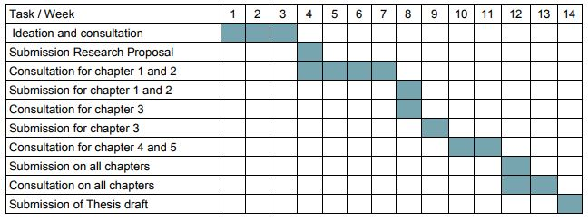
9) Reference list  List some references that you refer to for writing your background of the proposal or any references which are relevant to support your research proposal. | - Snyder, C. R. (2002). Hope theory: Rainbows in the mind. Psychological Inquiry, 13, 249-275.  - Allie Grasgreen. (2012). Inside Higher ED. Here’s Hoping. Retrieved from https://www.insidehighered.com/news/2012/07/06/researchers-apply-hope-theory-boost-college-student-success
10) Keywords  must include 4 or 5 keywords which are strongly related to your research proposal | - Hope  - Behaviour  - Colour  - Decision  - Feeling
Note: The proposal will be translated to Chapter1; kindly discuss your research proposal with your Advisor. Submit this proposal in about 5 pages, 1.5 spacing.

